**Calculator Assumed**

**Circle and Cubic Functions**

Time: 45 minutes

Total Marks: 45

Your Score: / 45



**Question One: [1, 3, 3, 1, 3 = 11 marks]**

Consider the function 

1. State the coordinates of the vertical intercept.
2. State the roots of .
3. Determine the turning points of  and their nature.
4. How many solutions are there to the equation ?
5. For what values of *k* does the equation have only one solution?

**Question Two: [6, 3, 2, 3 = 14 marks]**

1. Determine the equation of graphs A and B drawn below.

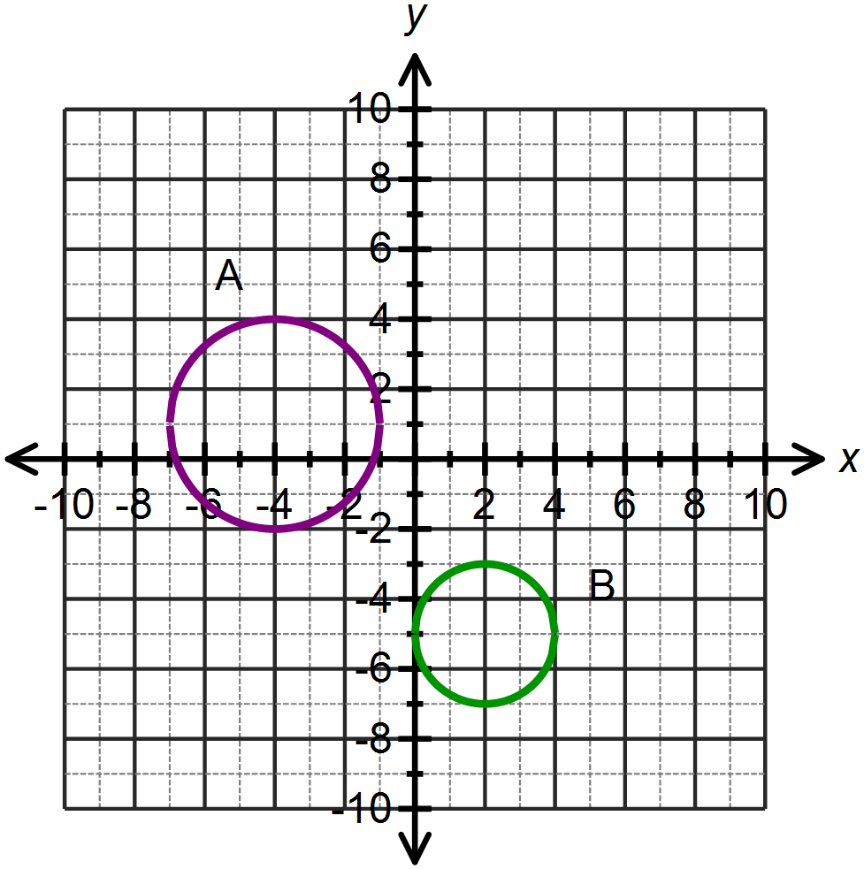

A:

B:

1. State the equation of the circle with a radius of 2 units and a center at the midpoint between the centers of A and B.
2. Sketch your solution to part (b) on the graph above.
3. For graph B, determine the equation of the function with range 

**Question Three: [6 marks]**

Match each of the following functions with the graphs below.

|  |  |
| --- | --- |
| 1. | 2. |
| 3. | 4. |
| 5. | 6. |
| 7. | 8. |
| 9. | 10. |

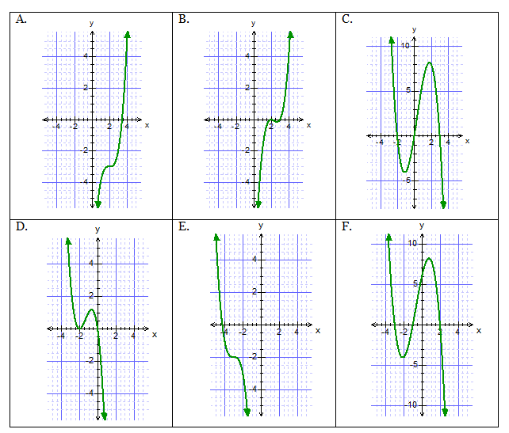

**Question Four: [4, 3 = 7 marks]**

The function  has three factors.

 is one of the factors of 

When is divided by , the remainder is 50.

1. Determine the values of *p* and *q* using the above information and showing all working.
2. Hence or otherwise determine the three *x* intercepts of the function .

**Question Five: [1, 2, 2, 2 =7 marks]**

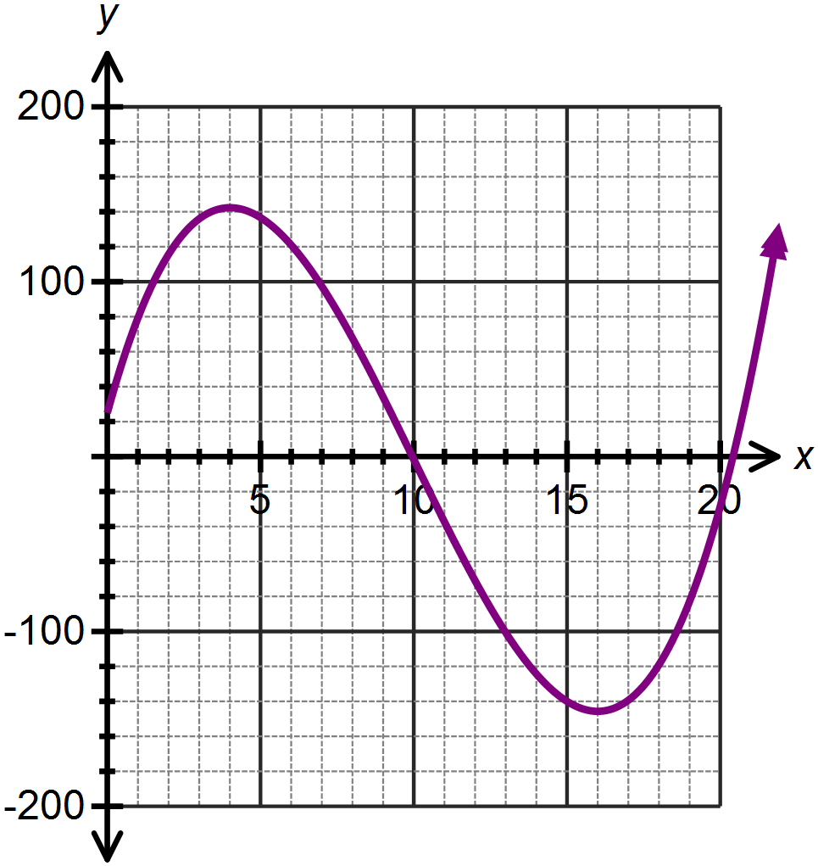Declan is trialing a new promotional strategy with the Facebook page for his small business. The number of “page likes” received each day since the start of his new campaign is found to be modeled by the following function, where *L* is the number of new “page likes” each day and *x* is the number or days since the commencement of the campaign.



1. Before commencing the campaign, how many new “page likes” could Declan expect to receive each day?
2. For how many days does the new strategy seem to gain results above his initial results? Explain your answer.
3. (i) At the most successful point in the campaign, how many new page likes did Declan receive?

(ii) Express his highest number of likes as a percentage increase on his inital result.

1. Over what domain does the function adequately model the situation?

**SOLUTIONS**

**Calculator Assumed**

**Circle and Cubic Functions**

Time: 45 minutes

Total Marks: 45

Your Score: / 45



**Question One: [1, 3, 3, 1, 3 = 11 marks]**

Consider the function 

1. State the coordinates of the vertical intercept.



1. State the roots of .



1. Determine the turning points of  and their nature.



1. How many solutions are there to the equation ?

3

1. For what values of *k* does the equation have only one solution?



**Question Two: [6, 3, 2, 3 = 14 marks]**

1. Determine the equation of graphs A and B drawn below.

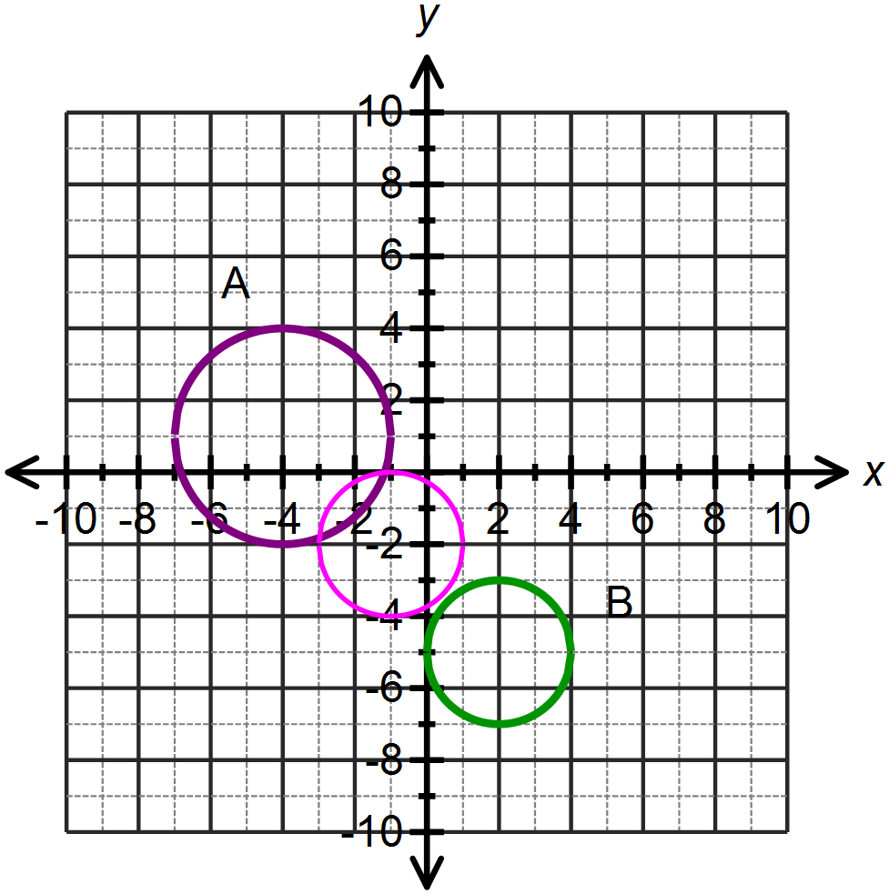

A:

B:



1. State the equation of the circle with a radius of 2 units and a center at the midpoint between the centers of A and B.



1. Sketch your solution to part (b) on the graph above.
2. For graph B, determine the equation of the function with range 



**Question Three: [6 marks]**

Match each of the following functions with the graphs below.

|  |  |
| --- | --- |
| 1.  D | 2.  C |
| 3.  B | 4.  F |
| 5. | 6.  A |
| 7. | 8. |
| 9. | 10.  E |



**Question Four: [4, 3 = 7 marks]**

The function  has three factors.

 is one of the factors of 

When is divided by , the remainder is 50.

1. Determine the values of *p* and *q* using the above information and showing all working.





1. Hence or otherwise determine the three *x* intercepts of the function .



**Question Five: [1, 2, 2, 2 =7 marks]**

Declan is trialing a new promotional strategy with the Facebook page for his small business. The number of “page likes” received each day since the start of his new campaign is found to be modeled by the following function, where *L* is the number of new “page likes” each day and *x* is the number or days since the commencement of the campaign.



1. Before commencing the campaign, how many new “page likes” could Declan expect to receive each day?



25

1. For how many days does the new strategy seem to gain results above his initial results? Explain your answer.

25 likes or above between day 0 and day 9.255, therefore the strategy works for 9 days.



1. (i) At the most successful point in the campaign, how many new page likes did Declan receive?



142 new page likes

(ii) Express his highest number of likes as a percentage increase on his inital result.



1. Over what domain does the function adequately model the situation?





